**Essay - Data Based Recommendations**

**The year 2020 hasn’t been anything like expected and most of all, our plans have gone awry. Where life has come to a standstill, it will take time and effort to get back to momentum.**

**The education of students has faced a major setback. Everyone is worried about how and if, schools should reopen in the near future. Classrooms are closed areas with students from different backgrounds. Washrooms, areas near the coolers, canteens, staffrooms are places where it’s difficult to keep a track of the entry and exit of the number of people and even more tedious to maintain a cent percent virus free environment.**

**A few things to consider when educational institutions are involved: a. Children are asymptomatic and shall spread germs unknowingly.**

**b. Children and staff members with mild cough, cold or fever often attend school which can prove fatal.**

**c. In case a child or teacher tests Covid positive who all should be quarantined – the entire class, the teachers or the entire school?**

**The pie-chart depicts the survey taken on reopening schools :**

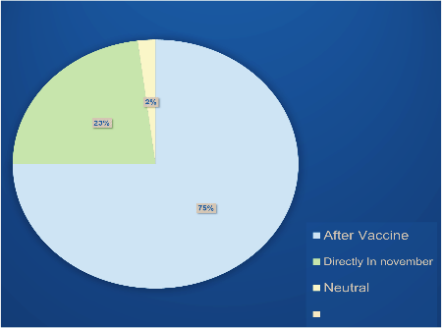

**Another area of concern besides sanitizing is social distancing in schools. How can that be taken care of – by standing one metre away? Teachers, parents, educationists, ministers and children themselves have their opinions backed up by valid reasons. All surveys, graphs and talks unanimously shout out loud – ‘No reopening of schools in the near future’.**

**Man is a social being and socialization is necessary. If social distancing has to be maintained to stop the virus from spreading then how will there be socialization? Hence, social gatherings must be under strict norms.**

**a. Use of masks, gloves and face shields must become the new normal.**

**b. Packed food and beverages must be given preference over serving food openly.**

**c. Sanitizing and washing hands frequently must be adhered to.**

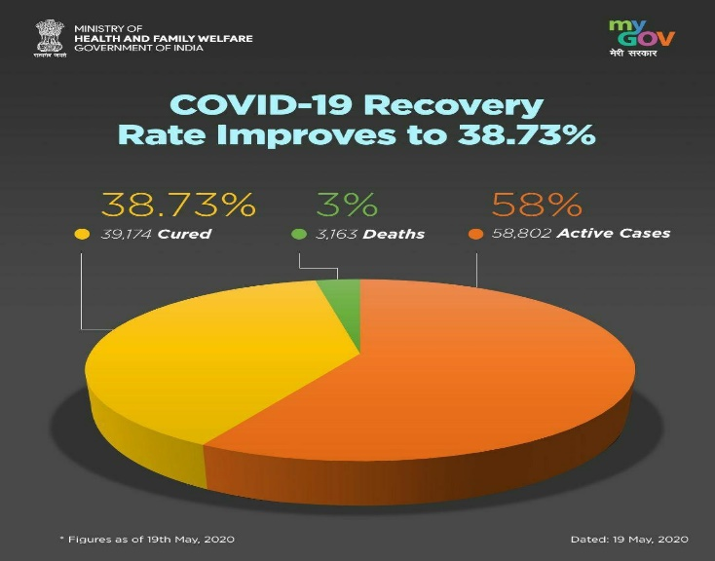**d. The crisis demands gatherings with limited people, just our near and dear ones.**

**The health and safety of each one of us is of prime importance. Stay away from mass gatherings yet stay connected.**

**Stay Home! Stay Safe!**

**Thank you Sonal Jaiswal**

**\*\*\*\*\*\*\*\*\*\*\*\*\*\*\***